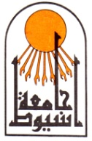

Assiut University
Faculty of Medicine
Dept. of Otorhinolaryngology

CURRICULUM VITAE

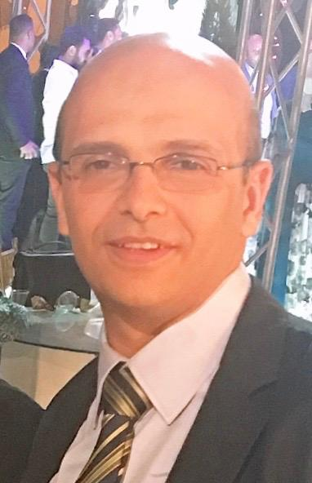

Mohammed Mahmoud Mohammed Roushdy
Assistant Porf. of Otorhinolaryngology, Faculty of Medicine
Assiut University, Assiut, Egypt.

Mobile: (+20)1005630198
Office: (+20)88 2413538
Fax: (+20)882333327
E-Mail: mohammedroushdy@aun.edu.eg
rosh26999@yahoo.co.uk
Last update: October, 2020.

Personal data:
Name: | Mohammed Mahmoud mohammed Roushdy
Birth date: | October 2nd, 1980
Sex: | Male.
Nationality: | Egyptian.
Marital Status: | Married and has one male and two females children.

Professional Title and Address:

Assistant Prof. of Otorhinolaryngology, Faculty of Medicine, Assiut University, Egypt.

Present occupation:

Assistant Prof. of Otorhinolaryngology, Assiut University Hospital, Assiut, Egypt.

Educational Background:

December 2013: M.D. in Otorhinolaryngology, Faculty of Medicine, Assiut University, Egypt.

September 2007: M.Sc. in Otorhinolaryngology, Faculty of Medicine, Assiut University, Egypt. (With general grade of Very Good).

September, 2003: M.B.B.Ch in Surgery and Medicine, Faculty of Medicine, Assiut University, Egypt. (With general grade of Excellent with Honor).

Training Experience:

From 3/2004 to 2/2005: Intern, Assiut University Hospital, Assiut, Egypt.

From 3/2005 to 2/2008: Resident of Otorhinolaryngology, Assiut University Hospital, Assiut, Egypt.

From 3/2008 to 1/2014: Assistant lecturer of Otorhinolaryngology, Assiut University Hospital, Assiut, Egypt.

From 3/2009 to 2/2010: Full time training in Maxillofacial and Plastic surgery department, Faculty of dentistry, Alexandria University, Egypt.

From 1/2014 to 1/2019: Lecturer of Otorhinolaryngology, Assiut University Hospital, Assiut, Egypt.

From 1/2019 till now: Assistant Prof. of Otorhinolaryngology, Assiut University Hospital, Assiut, Egypt.

Surgical experience:

Full spectrum of management (diagnostic, medical and surgical treatment) in Otorhinolaryngology with special interest in:

Head and neck surgery (including head and neck tumors, tracheal stenosis and salivary gland surgeries).

Obstructive sleep apnea and snoring surgery.

Voice rehabilitation and total laryngectomy.

Otologic surgeries (including tympanoplasty, middle ear prosthesis and cholesteatoma surgeries).

Nasal and paranasal sinus surgeries (including open and endoscopic procedures)

Full spectrum of management of trauma and emergencies of Otorhinolaryngology and airway.

Duties (March 2008 – up to date):

Performing operations two days a week.

Teaching undergraduate medical students.

Teaching post-graduate students along the house officer- training program.

Supervising and directing residents and fellows in (preoperative assessment and patient counseling- operative procedures - postoperative care.)

Helping in the research programs held at our department.

24 hours shift, once a week, as a consultant, dealing with ENT emergencies and trauma.

Consultant in the outpatient clinic two days per week.

Participation in the weekly seminar of our department.

M.Sc. Thesis:

Endoscopic ear surgery. (Essay)

M.D. Thesis:

Retrospective study on the effectiveness and indications of different types of flaps used for reconstruction of head and neck.

Courses and Workshops:
- 5th functional septorhinoplasty course (hands on dissection) in Ain shams university specialized hospitals 2008.
- Basic microsurgery workshop zagazig faculty of medicine (hands on course) 2011(40 credit hours).
- 34th workshop on basic Endoscopic Sinus Surgery (hands on dissection) Kasr Al-Aini Hospital,2014(24 credit Hours CME).
- 3rd workshop on advanced Endoscopic Sinus Surgery (hands on dissection) Kasr Al-Aini Hospital,2016(24 credit Hours CME).
- Egypt Dissection Program of ENT Head and neck workshop, El-hussein University Hospital, AlAzhar University 2015. (Instructor)
- The 20th international Training Course in Scientific Writing and Publications, Assiut University Hospitals, Assiut University 2018.
- Advanced Workshop in:” Student Assessment in Medical Education” Faculty of Medicine Quality Assurance Unit, Assiut University, March 2014.
- Advanced Workshop in:” Teaching Methods in Medical Education” Faculty of Medicine Quality Assurance Unit, Assiut University, March 2014.
- The 9th Alexandria Snoring& Obstructive Sleep Apnea Surgery Courses. Alexandria university hospitals, April 2019. (7 credit hours)

Conferences attended:
- The 2nd conference of Otorhinolaryngology in Assiut 2006(organizer).
- The 3rd conference of Otorhinolaryngology in Assiut 2008(organizer).
- The 5th conference of Otorhinolaryngology in Assiut 2012(organizer).
- The 6th conference of Otorhinolaryngology in Assiut 2014(speaker & organizer).
- The7th conference of Otorhinolaryngology in Assiut 2016(speaker& organizer).
- The 8th conference of Otorhinolaryngology in Assiut 2017(speaker& organizer).
- The 7th Meeting RhinoAlex October 2015.
- The 8th Meeting RhinoAlex October2016.
- The 9th Meeting RhinoAlex October 2017.
- The 10th Meeting RhinoAlex October 2018 (speaker).
- 11th Annual Meeting of the plastic Surgery department, Sohag 2013(speaker).
- The 30th Alexandria International Combined ORL Congress, April 2013 (27.5 Hours Category I Credit of the AACME Designation).
- 34th Summer Meeting of ESPRS Alexandria 2009.
- 2nd Annual Conference of the integrated Medicine & Sleep disorders Society.
- 2nd Aswan conference of otorhinolaryngology March 2016 (speaker).
- 3rd Aswan conference of otorhinolaryngology March 2017 (speaker).
- 4th Aswan conference of otorhinolaryngology March 2018 (speaker).
- The 36th Alexandria International Combined ORL Congress, April 2019 (27.5 Hours Category I Credit of the AACME Designation).

General Interests and Skills

Computer work and Information Technology

Sports: Swimming and chess.

Mother language: Arabic.

Foreign Languages:

English

French(fair).

References:

Prof. Dr. Ezzat Mohamed Saleh
Professor of Otorhinolaryngology Department, Assiut University Hospital, Assiut, Egypt. Assiut 71516, P.O. Box 110, Egypt. Tel. (+2088)(2306464), (+2088)(22348913), Email: emsaleh20@hotmail.com

Prof. Dr. Ahmed Mohamed Mohamed Medra

Professor of Maxillofacial and plastic surgery and the head of the department, Faculty of Dentistry, Alexandria University. Tel. (+20127392027), Email: profahmedmedra@hotmail.com

References and certificates are available on demand.

